TASK 3   
  
Screenshots :  
  
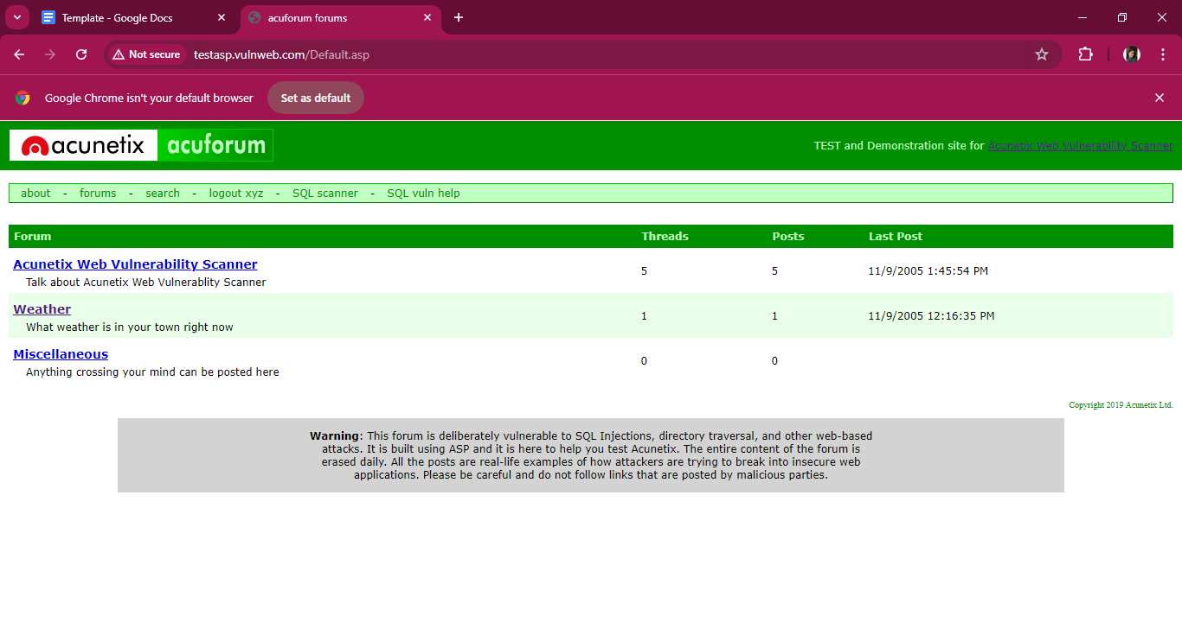  
  
  
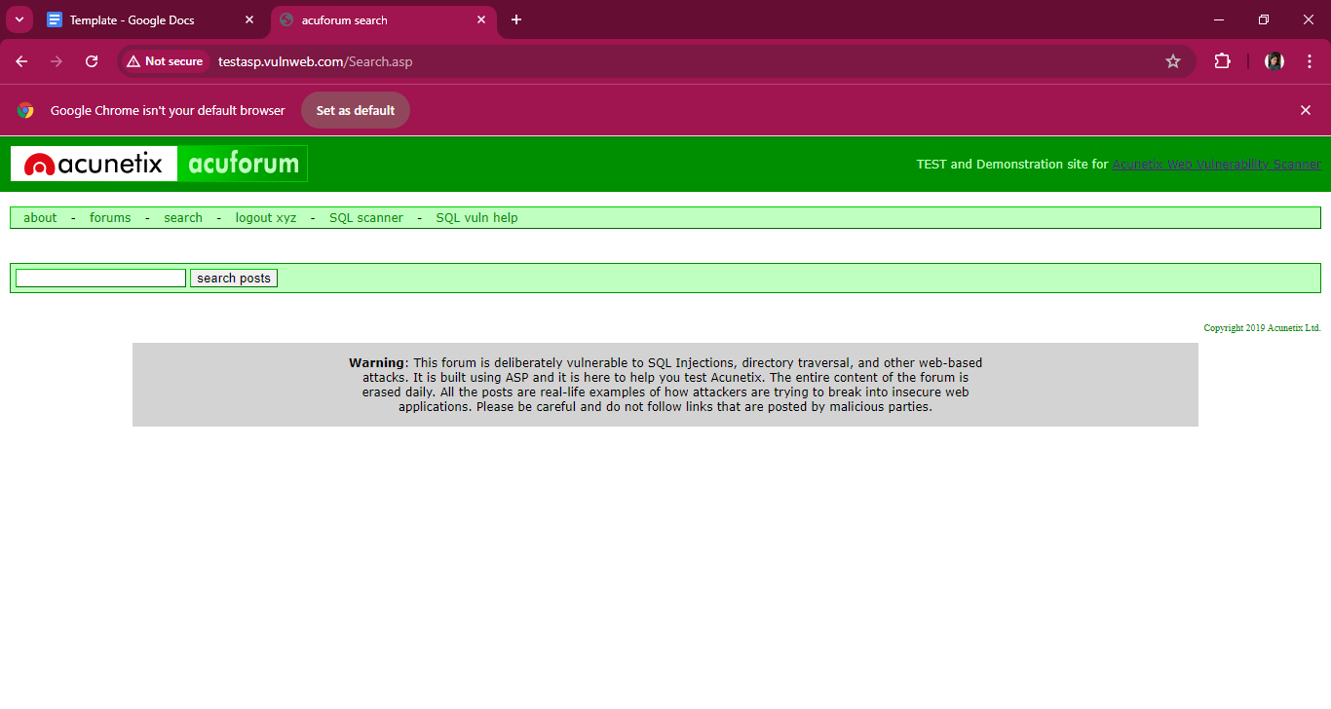  
  
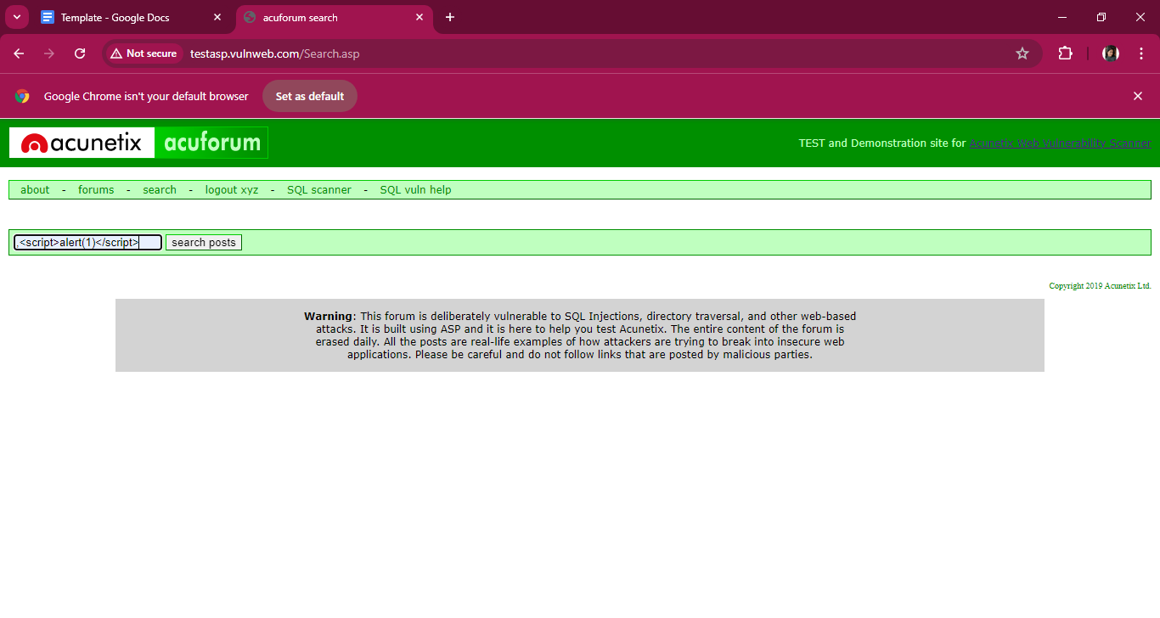  
  
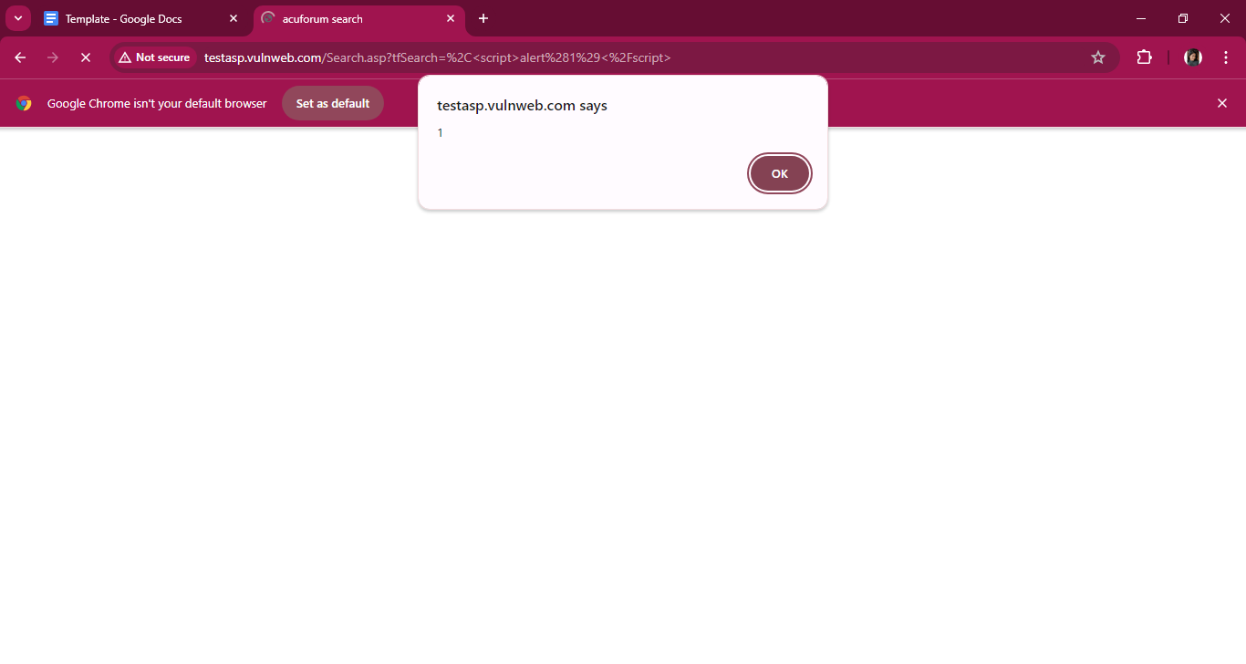  
  
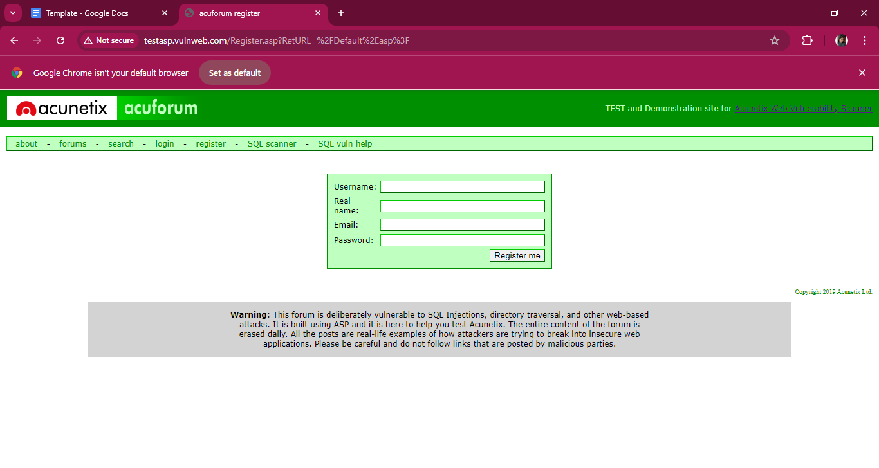  
  
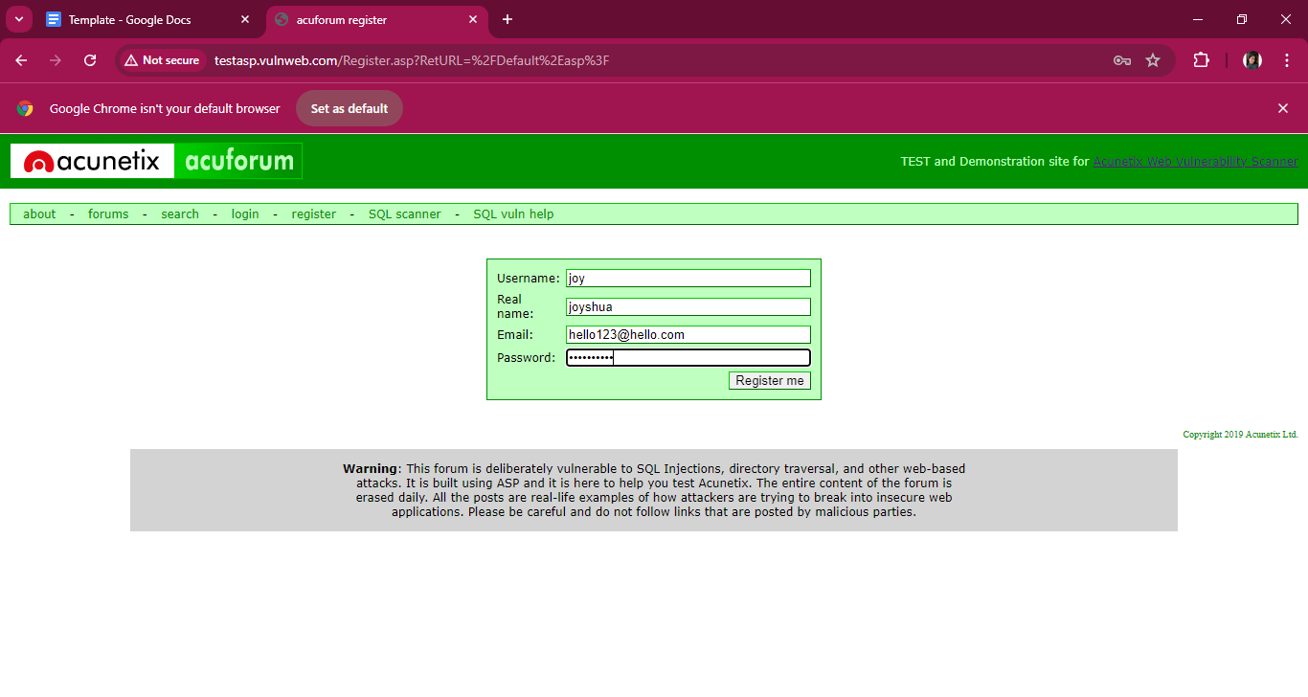  
  
  
  
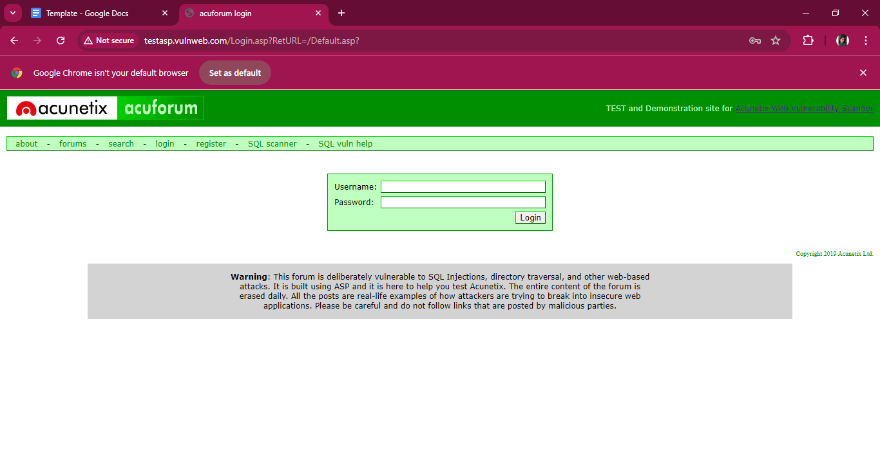  
  
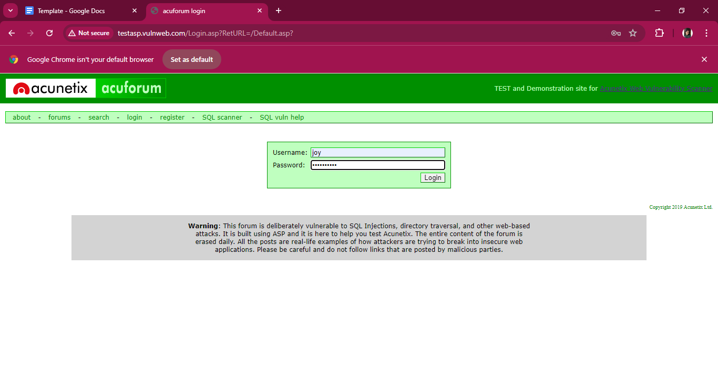  
  
  
  
  
  
  
  
  
  
**Video:**   
  
<https://drive.google.com/file/d/1T1nMyc-ANJbtkS3Z2cRpscKG9_peGKG1/view?usp=drive_link>

**REPORT :**Vulnerability Type: Cross-Site Scripting   
URL : http://testvulnweb.com

Domain: http://testasp.vulnweb.com/Search.asp

**Steps to Reproduce:**

Step 1: Identifying the Vulnerable Input

Navigate to http://testvulnweb.com/Search.asp

Step 2: Testing for XSS

XSS payload: <script>alert(1)</script>

Step 3: Observing the Results

If the script alert box appears with the message '1',

the vulnerability is confirmed.

**Impact:**

An XSS vulnerability allows attackers to inject malicious scripts into web pages viewed by other users.

**Mitigation:**

Ensure that all user inputs are validated and sanitized on the server side.